**  
  
**Command used :**

hdfs dfs -mkdir dir01

hdfs dfs -touchz /user/$USER/input1.txt

hdfs dfs -touchz /user/$USER/input2.txt

hdfs dfs -touchz /user/$USER/input3.txt

hdfs dfs -mv input*.txt /user/$USER/dir01/

hdfs dfs -ls /user/$USER/dir01/

hdfs dfs -setrep 5 /user/$USER/dir01/*

hdfs dfs -ls /user/$USER/dir01/

hdfs dfs -mkdir /user/$USER/scenario01

hdfs dfs -mkdir /user/$USER/scenario01/level01

hdfs dfs -mkdir /user/$USER/scenario01/level01/level02

hdfs dfs -cp /user/$USER/dir01/input1.txt /user/$USER/scenario01/

hdfs dfs -cp /user/$USER/dir01/input2.txt /user/$USER/scenario01/level01/

hdfs dfs -cp /user/$USER/dir01/input3.txt /user/$USER/scenario01/level01/level02/

hdfs dfs -ls -R -h /user/$USER/scenario01/

**Problem Statement 02:  
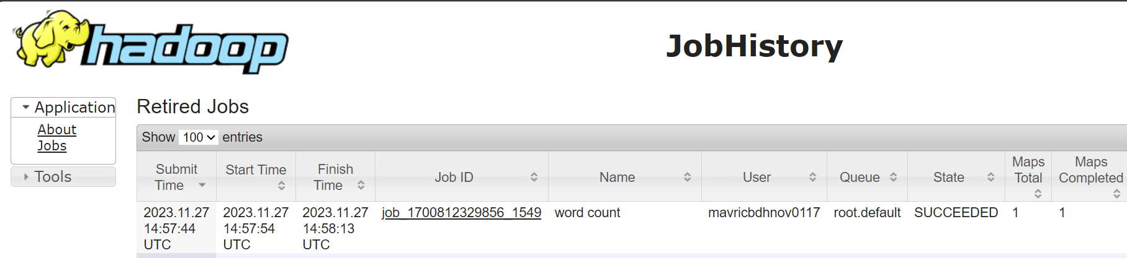**

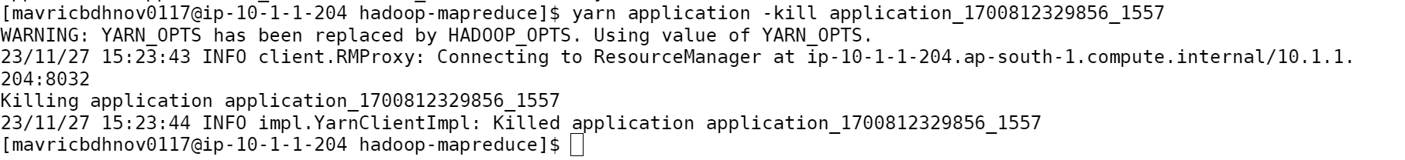

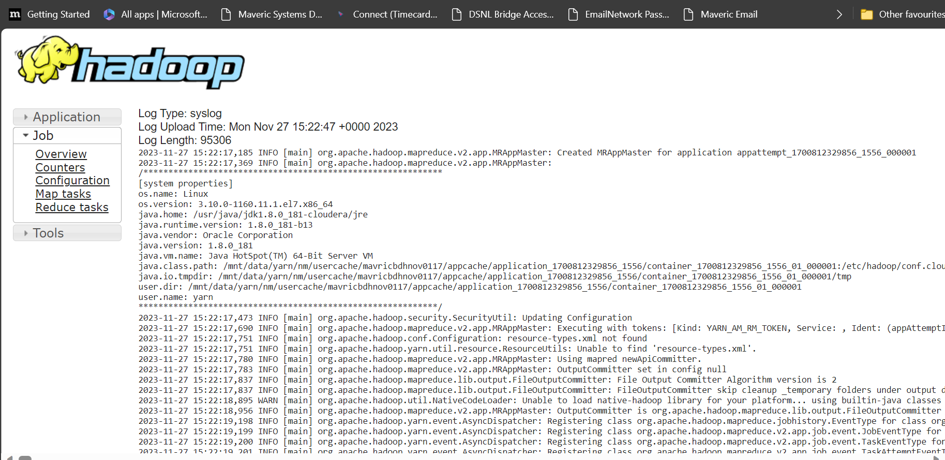**Command Used :**

cd /opt/cloudera/parcels/CDH-6.2.1-1.cdh6.2.1.p0.1425774/lib/hadoop-mapreduce/

yarn jar hadoop-mapreduce-examples.jar wordcount /user/$USER/workspace/ /user/$USER/output5/

yarn application -list -appStates RUNNING

yarn application -kill application_1700812329856_1557